Dear committee
We have just come back from the Victorian young riders championship. It was a great atmosphere with riders from south Australia, WA, NSW, as well as Tasmania.
I was told by one of the nsw Mums that the other state riders had been put in a composite team, and that team won the teams event.
It is very good of Victoria to allow us to compete at their event.
I had a good event winning the novice championship there were 28 riders in each class.
I would like to thank DAT and ETAS and the department of Sport and Rec for the funding and opportunities they provide for the young riders.
This year we have had training days and the annual Maria clinic, we are lucky to be able to train with a 5* international judge.
I have written to all the sponsors of the event and saw the organisers personally and thanked them for the opportunity to ride.
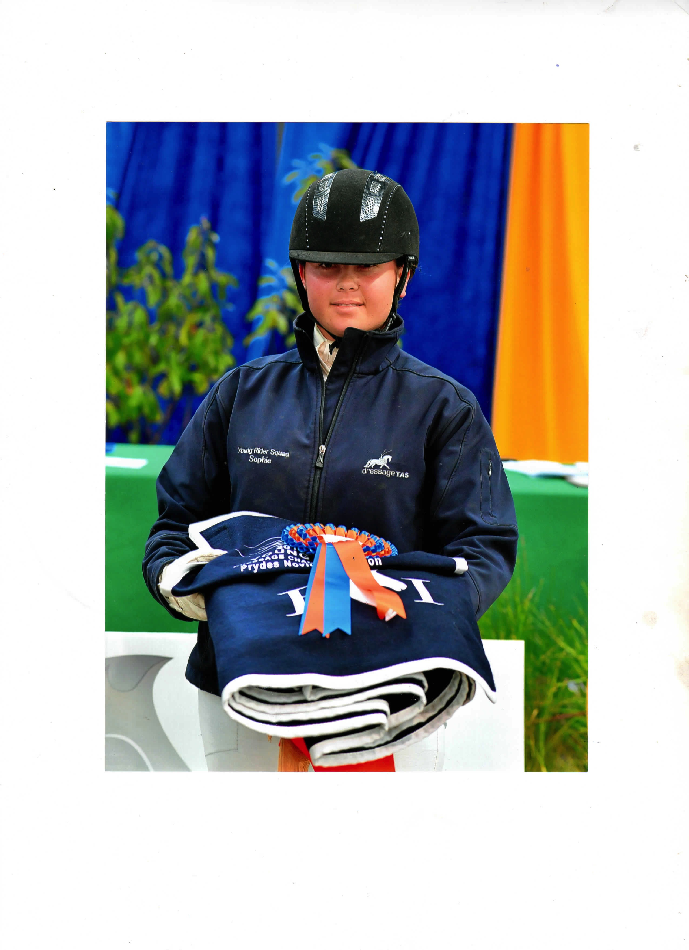
Mum judged and donated her fee back to the Victorian dressage judge education programme as they had helped her with her shadow judging exams.

Thank you
Sophie Mcdermott

