Event Risk Assessment and Preparedness

Club/Committee Name:

Location: |  | Event Date:
 |  | Start Date:
If other please describe | NA | Finish:
Event Coordinator:
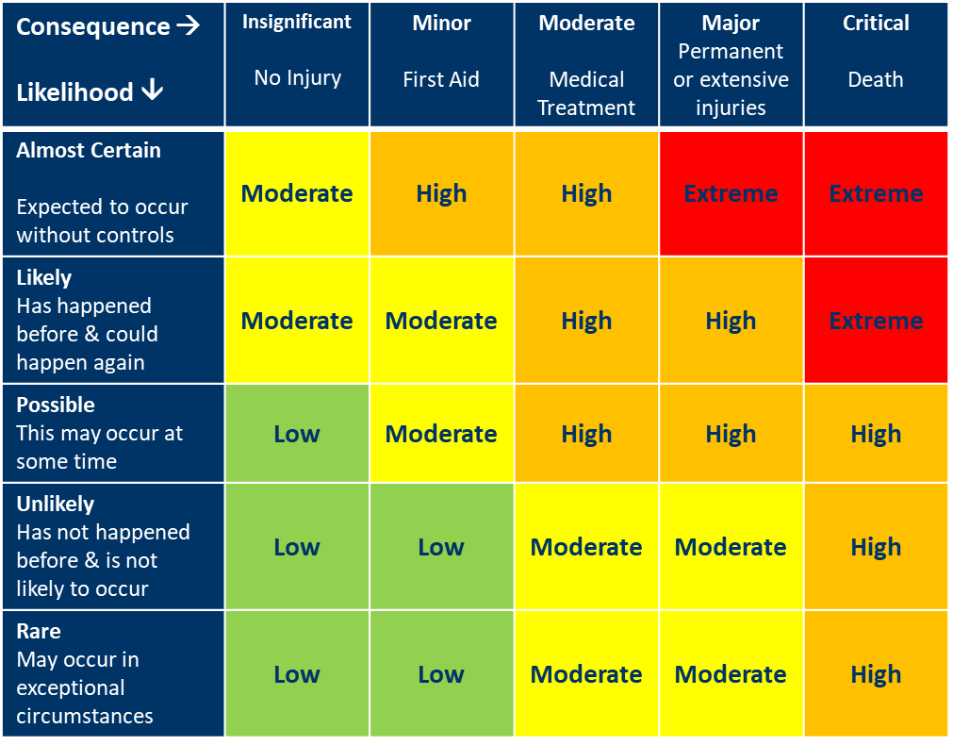

Risk Assessment & Management Plan
Please add rows and detail to your plan as required to cover all hazards identified
Hazard Source | Is this Hazard present?  (Yes/No) | Risk Rating?  Low  Moderate  High  Extreme | Risk Management Plan  A risk management plan must be completed for Risks rated High or Extreme | Implemented | Communicated | Assessed

Event Management
Access & Parking
Gates & Access
Roads
Truck /Horse Float Parking
Spectator Parking

Overnight Parking

Stable Access
Traffic Management - Vehicles
Vehicle routes
Speed
Judge and official vehicles
Traffic Management – Horses
Parking/ stabling to competition route
Horse/ vehicle crossing management
Camping, Stabling and Facilities
Camping Areas
Electricity Access
Stables
Toilets and Showers
Biosecurity
Biosecurity Hazards

Biosecurity (other)

Hazard Source | Is this Hazard present?  (Yes/No) | Risk Rating?  Low  Moderate  High  Extreme | Risk Management Plan  A risk management plan must be completed for Risks rated High or Extreme | Implemented | Communicated | Assessed

Field of Play
Surfaces and surrounds
Competition area location and condition
Warm-up location and condition
Jumps and other event equipment
Horse Hazards
Conditions or actions that could startle horses
Weather
Hot weather
Rain

Emergency Preparedness Plan / Serious Incident Management Plan
Roles and Responsibilities | Have the roles and responsibilities of the following people in managing risk at the event been documented and communicated?  (yes/ no/ NA) |  | Have the roles and responsibilities of the following people in responding to and managing incidents and injuries been documented and communicated  (yes/ no/ NA)
Event Organiser
Officials
Stewards
Event Committee
Technical Delegate
Ground Jury
Other – please specify

Emergency Response
 | Yes/No | Details
First Aid Providers required
First Aid Equipment onsite
Emergency Response Plan
Reporting Processes
Concussion Management

