Sydney CDI
By Caitlin Radford

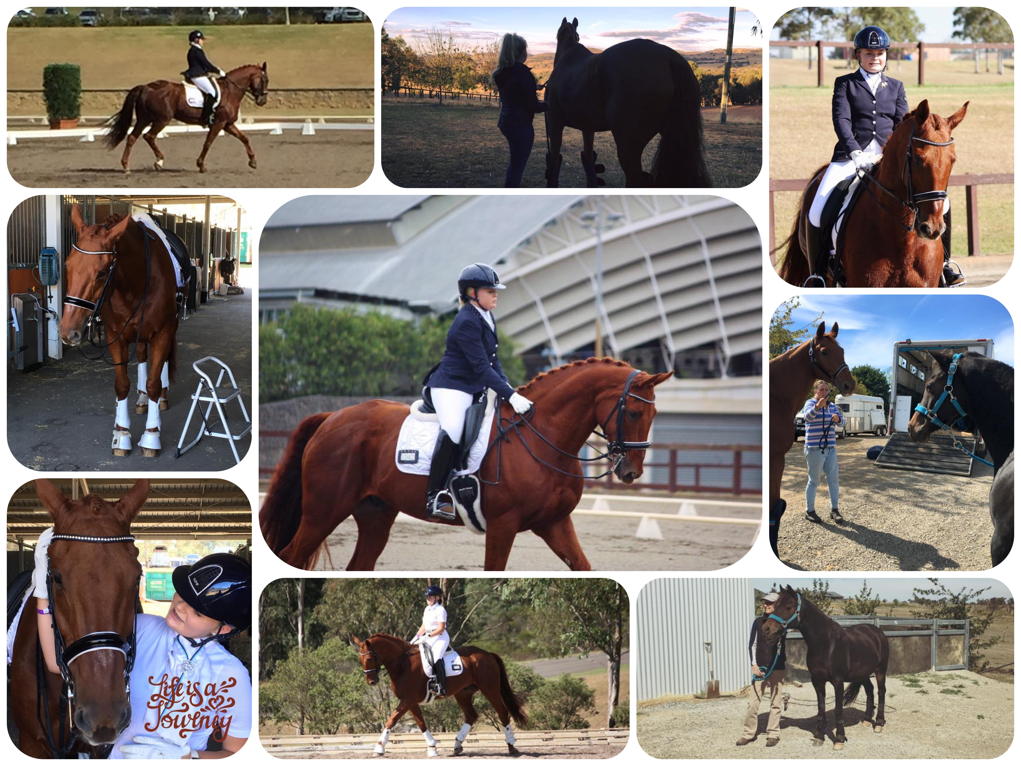

Wow what an incredible week I have had at the Sydney CDI! Our journey started with Boy, Mum, Cupcake and I on the boat on the 31st of March. Thank you so much to The Spirit of Tasmania and Groups Tasmania (David Luttrell) for sponsoring my trip away. Their support was amazing and very much appreciated! Once we had arrived in Melbourne we headed straight to Yass to stay with our good friends there. Boy then spent the week there in a paddock before his big journey to WA began (more on that later). Saturday and Sunday Mum and I traveled out to Callum Park to ride my big red head Professor Jay! On the Monday I had a lesson with Susan in the morning before the four of us (Jay, Cupcake, Mum and I) headed to Sydney to get all settled in for the week ahead! On Tuesday we had a lovely ride around Sydney International Equestrian Centre (SIEC) and a lesson with super coach Susan Elekessy. That night the Para riders all got together for our own little welcome party.

Wednesday saw the first day of competition. We had a lesson in the morning before Jay was washed and plaited and then we were on at 2.20pm. We had a great first test in the Team Test and achieved our goal of not doing any flying changes. We came third with a score of 65.63% even getting a 68.33% from one judge! Then Thursday saw the Individual Championship test. This test wasn't as good as the day before as Jay was a little more excited than Wednesday to be out there competing. We were on at 2.10pm and placed third once again with a score of 64.05%.

Then Friday was a rest (well a day of shopping) and our freestyle run through and sound check. Then Saturday came, the day I had been looking forward to the most. I love the freestyle day as it is fun and you can do your own thing if needed. I made Jay some new music as it was our first freestyle together. I love the music; it was from the movie Shrek! We only had one chance to go through the music and freestyle together so our timing wasn't quite right however the judges still loved it and we came out with a score of 68.92% with one judge even having us on 71.75%!! This was by far our best test of the week and he stayed with me the whole time and really listened and let me ride him. It was an incredible feeling. If only I hadn't lost my stirrup on the final centerline and caused an untidy finish we could have received an even better score!

Saturday night we got to sit back and relax watching the freestyles! Sunday we left SIEC and headed to Yass. Jay went on Sharon Jarvis' truck to keep Ceasy company. Then once we were at Yass Jay came off the truck and Boy went on! Boy is heading over to WA on lease for an up and coming 12 year old Para rider to teach her the ropes just like he taught me. I will miss him so much but I know that he is going to be well looked after and will enjoy having some fun!

I was so proud of Jay and my whole team this week and I felt as though this was my best competition in a long time! Jay was such a good lad considering he is still coming back into work and this was only his second competition in 12 months!! Now he gets to come home and we can get to know each other better.

A massive thank you to my sponsors:
-The Spirit of Tasmania for getting us across the water.
-Groups Tasmania and Remus rugs for organizing our trips away and Jay’s new rug.
-Equissage (Leanne Masters) for ensuring that Jay and I are always performing at our best.
-Dannebrog Cafe Bar and Grill for the ongoing support since the beginning of time.
-Saddle Savers by Sandbeck (Amanda Baker) for all of my awesome banners and gear protectors.
-Also to Disability Sports Tasmania for their support and my scholarship on my journey.
-Also the Tasmanian Institute of Sport who keep me fit and on top of my game for competition

Also thank you to Keira Linde Equestrian Services for doing such a great job with Jays plaits and to Jen Carroll for Jay’s massages and to Boutique Equine for my amazing hair do and new accessories (go and check them out!). Thank you to the Callum Park Team for all of your support and coaching through the comp and for the past few years. Without you I would not be where I am today! Finally thank you to the organizing committee, the EA Para team, fellow riders and horsey fiends, stewards, judges and volunteers etc. for such a great competition! The biggest thank you of all must however go to my family especially Mum, Dad and my brother for all of their support and for giving me all of these opportunities.

Thank you for reading, Caitlin xo

