Dressage Tasmania Horse of the Year 2023-24 Nomination Form

Horse, Pony, Young Rider, Off the Track Thoroughbred and Off the Track Standardbred
Please complete and return this form to:
Secretary, Dressage Tasmania: E-mail: dressagetasmania@outlook.com

Please complete the subject ﬁelds on the following page.

NOMINATIONS CLOSE MONDAY 15th APRIL 2024

Horse, Pony and Young Rider of the year will be awarded to the horse/pony/young rider who has gained the highest average percentage from 4 official performances at one level within the performance period (YR performances may come from any level).
Winner will receive an embroidered trophy rug, runner-up will receive an embroidered saddle blanket.

Performance Period: 4th March 2023 to 3rd March 2024 (inclusive)

Eligibility:
During the ‘Performance Period’:
- Horse/Pony must have been EA registered and hold an EA competition license
- Rider must be a current member of Dressage Tasmania.
- Horse and rider must reside in Tasmania.
- Performances must be obtained in Tasmania within the performance period.
- One performance may be included from National or Interstate Championships or CDI competitions whilst representing Tasmania.
- Ponies must have obtained a current official EA height certificate (please attach).

Performance Criteria:
- Preliminary to Advanced: Must provide 4 Official Performances at one level
(may nominate for more than 1 level)
- FEI: Must provide 2 Performances at small/medium/ big tour
- Young Rider: Must provide 4 Official Performances across any level
- Off the Track Must provide 4 Official Performances across any level. Horse must be registered with Australian Register of Racehorses
**FEI Small/Med/Big Tour; for the purposes of this award is defined as competing either level e.g. PSG/I1, Inter A/B, I2/GP.

Rider Name:
EA Member Number:
Address:

Phone:
Email:
Horse Name:
EA Number:
Current Grading:
Rug Size:
Horse Pony Young Rider Off the Track Thoroughbred
Off the Track Standardbred (please circle)

Performances:
Please include a screenshot of official performances as explained below.

Go to:
http://www.equestrian.org.au/members/search/dressage-results

Search for your horse’s name with the dates as above and attach to this form.

Please highlight your 4 best scores (or 2 for FEI) within the performance period.
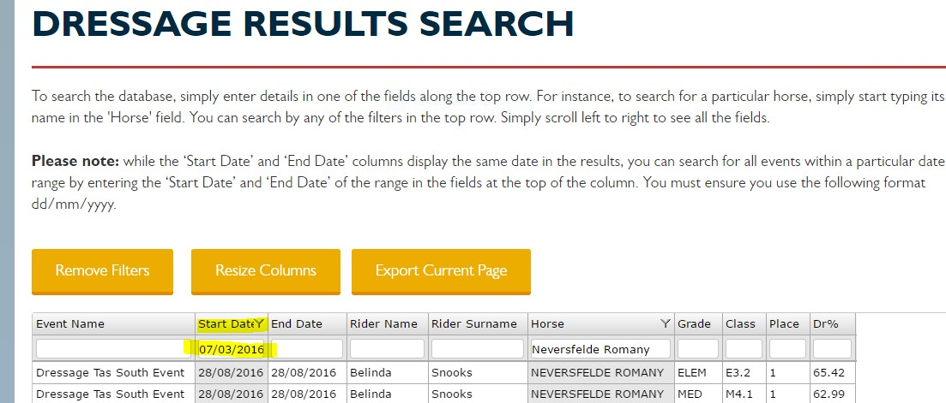
Example

